Test Cases

**Test Case 1:**

**Test Description:** In program frame populate the textfields and comboboxes and hit the insert new button

**Expected Result:** Entered information should be stored in the database and should bring back the information from database and show in the JTable

**Actual Result:**

Populated Fields

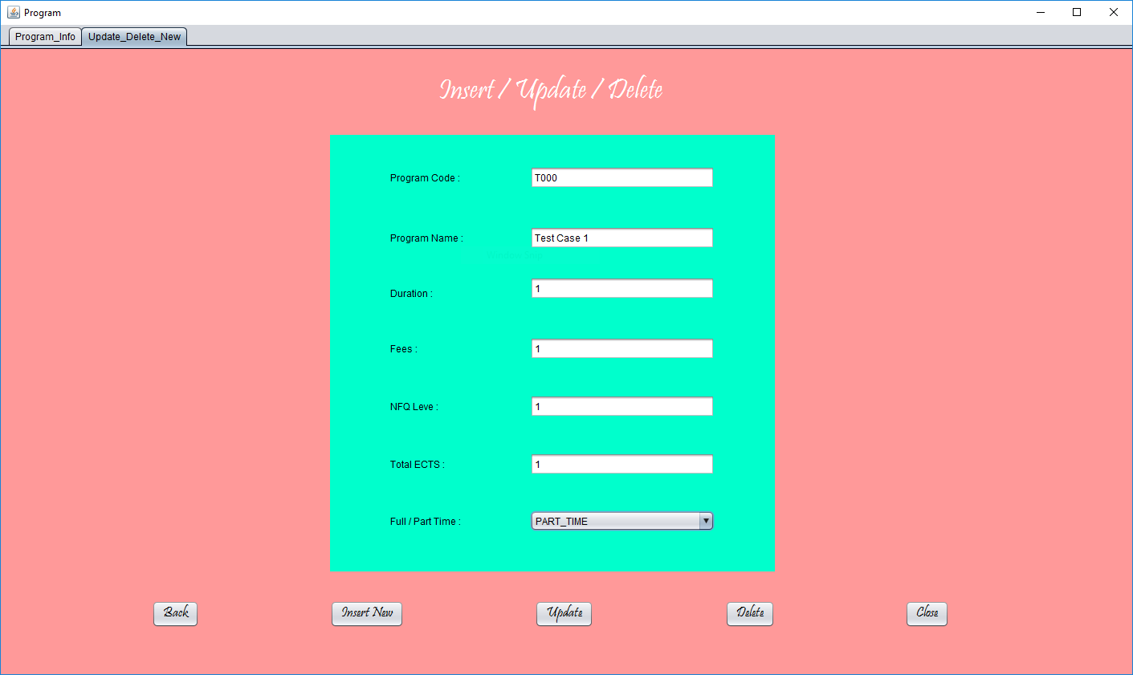

Before Inserting the Record



Inserting new Program Message

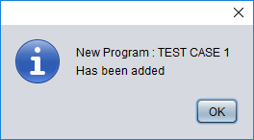

After Inserting the record

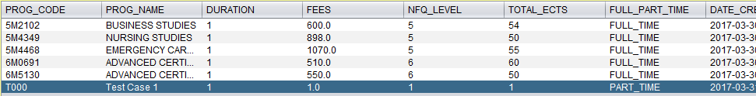

New Program has been Inserted in the database and brings back the information from database so this test case is Pass.

**Test case 2:**

**Test Description:**Select the program where program id is 5M4468 and set that program as part time

**Expected Result:**Program should be updated and set to Part Time Program

**Actual result:**

Before Updating the program



Updating information message

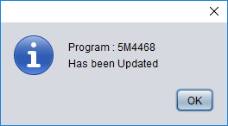

After Updating the program



Program has been updated so this Test case Pass

**Test Case 3:**

**Test Description:**Select the newly entered program name TEST CASE 1 and hit the delete button

**Expected Result:**This should delete the record from database and JTable should be updated

**Actual Result:**

Before deleting the record



Deleting Information Message

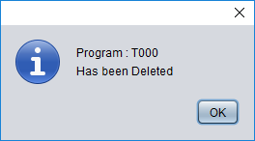

After deleting the program



Program is deleted from the database and disappeared from the JTable so this test case Pass

**Test Case 4:**

**Test Description:**On reports Frame Click the search button in order to generate a report where students and teachers don't have email or phone number

**Expected Result:**In JTable students and teachers records should be populated where email or phone number is missing

**Actual result:**

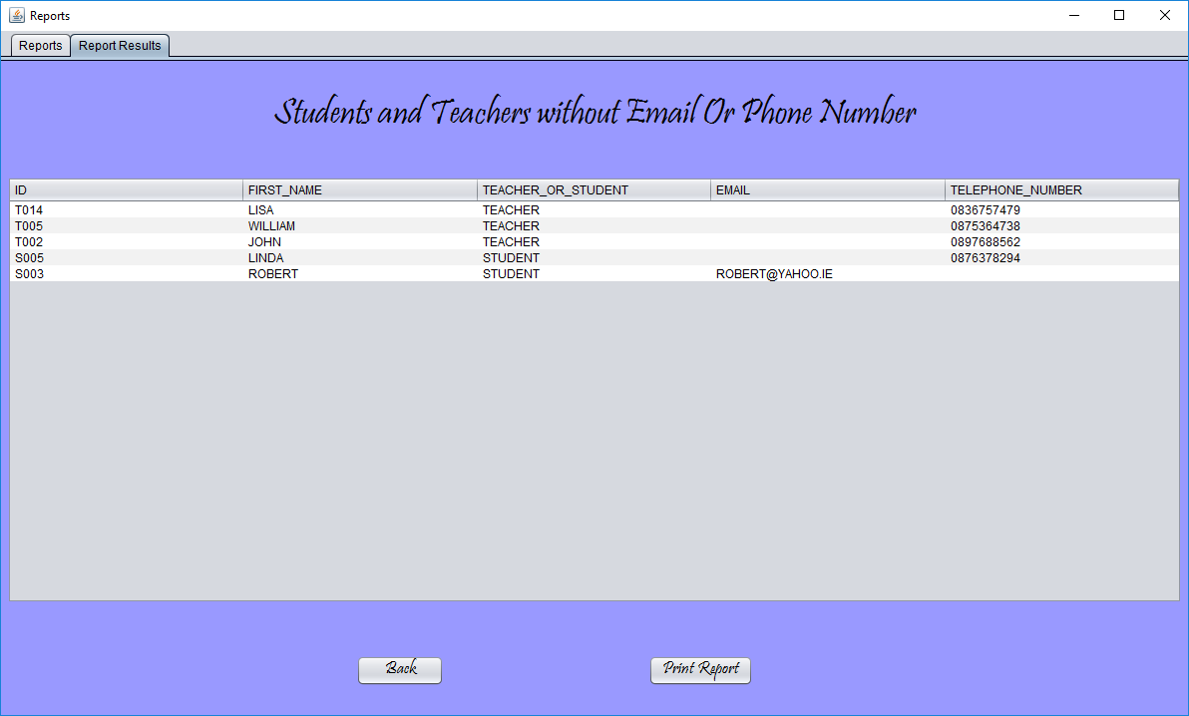

It's bringing back the desired result into the table so this test case Pass

**Test case 5:**

**Test Description:**Insert the result for a group where group id is BS01

**Expected Result:**While selecting the group id it should populate the list with the student

information belongs to the the selected group and insert the results for all the students at the same time

**Actual Result:**

Before Inserting the result table is empty

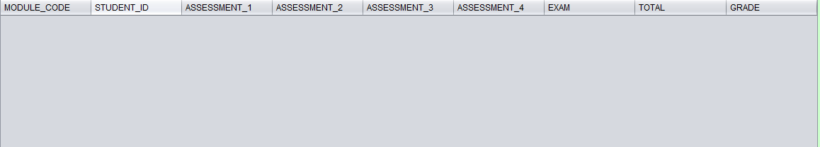

Selecting the group id and module id and insert the desired result into the test fields

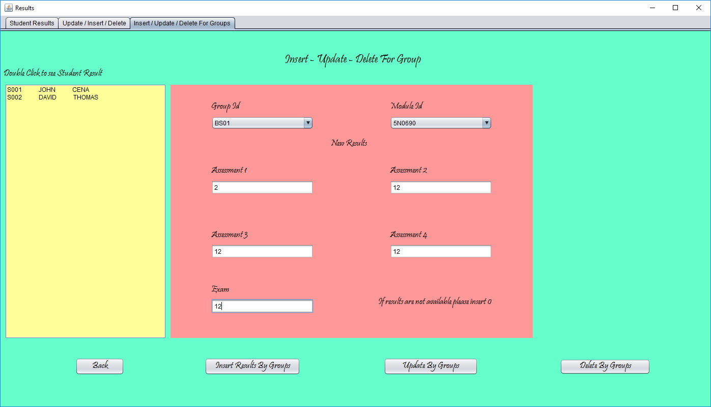

After inserting the results



Its inserting the result at the same time for the students belongs to the group BS01 so this test case Pass